Day 391 — Regression Revision
Complete Revision Notes | Linear, Multiple & Polynomial Regression • Assumptions • Prediction Workflow • Evaluation Metrics
Learning goal: master foundational and advanced regression analysis: formulate Simple Linear, Multiple Linear, Polynomial, and Regularized (Ridge, Lasso, ElasticNet) models; test Gauss-Markov assumptions; execute an end-to-end regression prediction workflow; interpret Mean Squared Error (MSE), Root Mean Squared Error (RMSE), Mean Absolute Error (MAE), and R² / Adjusted R²; and implement leak-free regression pipelines.

1. What is Regression Analysis?
Regression analysis is a fundamental supervised learning methodology used to model, understand, and predict the relationship between one or more independent predictor features (X) and a continuous, quantitative real-valued dependent target variable (y).
Unlike classification—which predicts categorical discrete classes or boundary probabilities—regression maps input feature spaces directly onto a continuous numerical continuum: f: ℝ^d → ℝ.
Regression Paradigm | Core Mathematical Formulation | When to Choose | Primary Limitation / Risk
Simple Linear Regression | y = β₀ + β₁x + ε | Single continuous feature predicting target (e.g., Square Footage -> Price) | Underfits when relationship has non-linear curves
Multiple Linear Regression | y = β₀ + β₁x₁ + β₂x₂ + ... + β_d x_d + ε | Multiple independent features influencing target simultaneously | Vulnerable to multicollinearity and high-dimensional overfitting
Polynomial Regression | y = β₀ + β₁x + β₂x² + ... + β_k x^k + ε | Capture non-linear curves while keeping linear optimization | Runaway boundary oscillations at high degrees (Runge's phenomenon)
Ridge Regression (L2) | Loss = OLS + λ Σ β_j² | Multicollinearity present; stabilizes large coefficients | Retains all features; does not perform sparse feature selection
Lasso Regression (L1) | Loss = OLS + λ Σ |β_j| | High-dimensional feature selection needed; sparse model desired | Arbitrarily selects one feature among highly correlated groups
ElasticNet Regression | Loss = OLS + λ₁ Σ |β_j| + λ₂ Σ β_j² | Many correlated features; combines stability and sparsity | Requires tuning two hyperparameters (λ and L1 ratio)

2. Simple Linear Regression & Ordinary Least Squares (OLS)
Simple Linear Regression models the linear association between a single scalar predictor x and a continuous target y. The true population relationship is expressed as: y = β₀ + β₁x + ε, where β₀ is the y-intercept, β₁ is the slope coefficient, and ε is an unobserved random error term.
Ordinary Least Squares (OLS) calculates the best-fitting line by minimizing the Residual Sum of Squares (RSS), which measures the sum of squared vertical differences between observed points and the predicted line.
OLS Closed-Form Formulas (Single Feature):

Cov(x, y) Σ (x_i − x̄)(y_i − ȳ)
Slope β₁ = --------- = ----------------------
Var(x) Σ (x_i − x̄)²

Intercept β₀ = ȳ − β₁ x̄

Where:
- x̄ = Sample mean of feature x
- ȳ = Sample mean of target y
- The fitted regression line ŷ = β₀ + β₁x is guaranteed to pass through (x̄, ȳ)

3. Multiple Linear Regression & Normal Equation
Multiple Linear Regression extends linear modeling to d independent features: y = β₀ + β₁x₁ + β₂x₂ + ... + β_d x_d + ε. In compact linear algebra matrix notation, this is expressed as: y = Xβ + ε, where X is an (n × (d + 1)) design matrix with a leading column of 1s representing the intercept.
Component | Matrix Dimension | Mathematical Description
Design Matrix (X) | n × (d + 1) | n observations across d features, plus a leading bias column of 1s
Parameter Vector (β) | (d + 1) × 1 | Column vector of learnable weights [β₀, β₁, ..., β_d]^T
Target Vector (y) | n × 1 | Observed continuous ground-truth target values
Predicted Vector (ŷ) | n × 1 | Model output: ŷ = Xβ = X(X^T X)^(−1) X^T y = Hy (where H is Hat Matrix)
Residual Vector (e) | n × 1 | Sample errors: e = y − ŷ = (I − H)y

Analytical Solution: The Normal Equation
Setting the gradient of the OLS cost function J(β) = (y − Xβ)^T (y − Xβ) to zero yields the exact closed-form solution known as the Normal Equation:
Normal Equation:
β = (X^T X)^(−1) X^T y

Computational Trade-offs:
- Pros: Exact global analytical solution; zero hyperparameters (no learning rate); no iteration.
- Cons: Inverting (X^T X) has computational complexity O(d^3); intractable when feature count d > 10,000.
- Failure Mode: If features are collinear, (X^T X) is non-invertible (singular). Use Gradient Descent or SVD.

4. Polynomial Regression: Modeling Non-Linear Relationships
Polynomial Regression models non-linear curvilinear relationships by creating power-transformed features (x², x³, ..., x^k). Although the relationship between y and x is non-linear, the model remains technically a linear model because it is strictly linear with respect to the unknown parameters β.
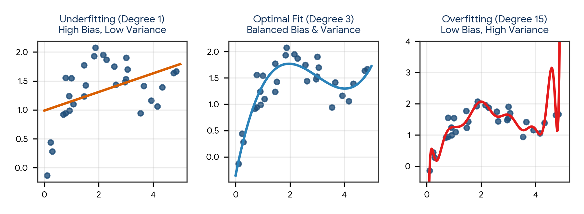
Figure 1. Polynomial degree comparison: Degree 1 underfits (high bias), Degree 3 fits optimally, Degree 15 overfits (high variance).
Degree (k) | Model Complexity | Training Error | Test Error | Diagnostic State
Degree 1 (Linear) | Too simple; straight line cannot follow non-linear trajectory | High | High | Underfitting (High Bias)
Degree 2–3 (Moderate) | Balanced; captures true underlying curvature smoothly | Low | Low | Optimal Generalization
Degree 10+ (High) | Excessive; fits training noise and oscillates wildly at edges | Zero / Near Zero | Extremely High | Overfitting (High Variance)

5. The Classical Gauss-Markov Assumptions of Linear Regression
The Gauss-Markov Theorem establishes that under five foundational assumptions, the OLS estimator is BLUE: Best Linear Unbiased Estimator (unbiased with minimum variance among all linear estimators). Violating these assumptions leads to biased coefficients or invalid p-values.
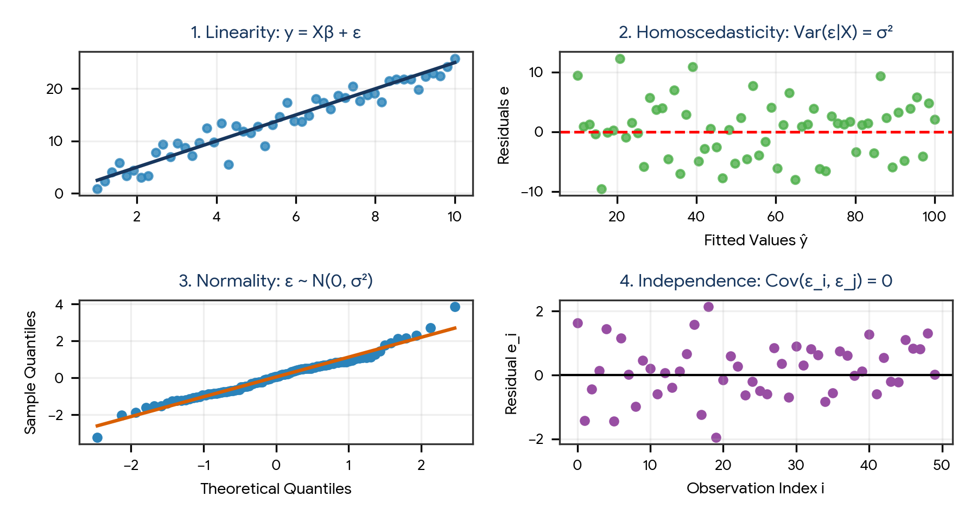
Figure 2. Diagnostic visual tests for the 4 core residual assumptions: Linearity, Homoscedasticity, Normality, and Independence.
Assumption | Theoretical Definition | Violation Symptom | Diagnostic Tool | Remediation Strategy
1. Linearity in Parameters | y is a linear combination of parameters β: y = Xβ + ε | Residuals show clear curved pattern vs fitted values | Residuals vs Fitted plot | Apply non-linear transformations (log, sqrt) or polynomial features
2. Strict Exogeneity | E(ε | X) = 0 (Errors have mean zero and are uncorrelated with X) | Omitted variable bias; endogeneity; biased coefficients | Domain causality audit | Include missing confounders or use instrumental variables
3. Homoscedasticity | Var(ε | X) = σ² (Constant residual variance across all fitted values) | Funnel/cone shape in residual plot; standard errors biased | Breusch-Pagan test; White test | Apply log1p(y) or Box-Cox transformation; Weighted Least Squares (WLS)
4. Independence (No Autocorrelation) | Cov(ε_i, ε_j) = 0 for all i ≠ j (Errors are mutually uncorrelated) | Consecutive runs of positive or negative errors in time | Durbin-Watson test (stat ≈ 2.0) | Use ARIMA, TimeSeriesSplit, or Newey-West robust standard errors
5. No Multicollinearity | No predictor is a perfect linear combination of other predictors | Unstable coefficients; huge standard errors; sign flips | Correlation matrix; VIF > 5.0 | Drop collinear features; use PCA; apply Ridge / Lasso regularization

6. Comprehensive Regression Evaluation Metrics
Evaluating regression models requires quantifying prediction error magnitude and proportional variance explained. Unlike classification accuracy, regression metrics operate on continuous residual errors: e_i = y_i − ŷ_i.
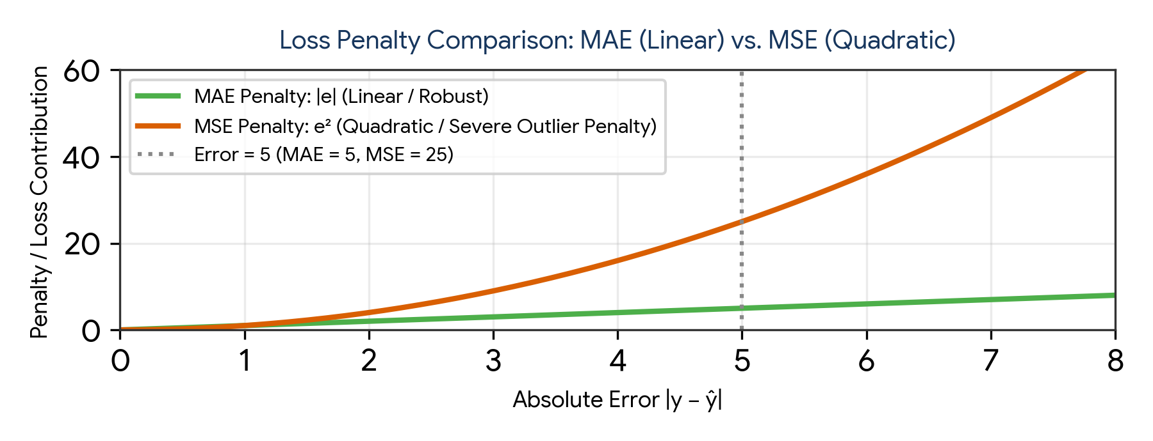
Figure 4. Loss penalty comparison: MAE penalizes errors linearly, while MSE penalizes large errors quadratically.
Metric | Mathematical Formula | Units | Outlier Sensitivity | Primary Practical Application
Mean Absolute Error (MAE) | MAE = (1 / n) Σ |y_i − ŷ_i| | Same units as target y | Low (Robust) | Direct interpretation of average absolute dollar/unit deviation; ideal when outliers exist
Mean Squared Error (MSE) | MSE = (1 / n) Σ (y_i − ŷ_i)² | Squared units of target y² | Extremely High | Mathematical optimization objective during model training (smooth gradient everywhere)
Root Mean Squared Error (RMSE) | RMSE = sqrt(MSE) | Same units as target y | High | Standard benchmark metric; penalizes large catastrophic prediction misses heavily
Mean Absolute Percentage Error (MAPE) | MAPE = (100% / n) Σ |(y_i − ŷ_i) / y_i| | Percentage (%) | High if y ≈ 0 | Executive reporting and business forecasting; undefined when actual y_i = 0
R² (Coefficient of Determination) | R² = 1 − (SSE / SST) | Dimensionless (−∞ to 1.0] | High | Proportion of target variance explained by features relative to simple baseline mean ȳ
Adjusted R² | 1 − [ (1 − R²)(n − 1) / (n − d − 1) ] | Dimensionless (−∞ to 1.0] | High | Model selection; penalizes adding uninformative features that artificially inflate raw R²

Decomposing the Total Sum of Squares (SST = SSR + SSE)
R² measures the proportion of total variation in y explained by the regression model:
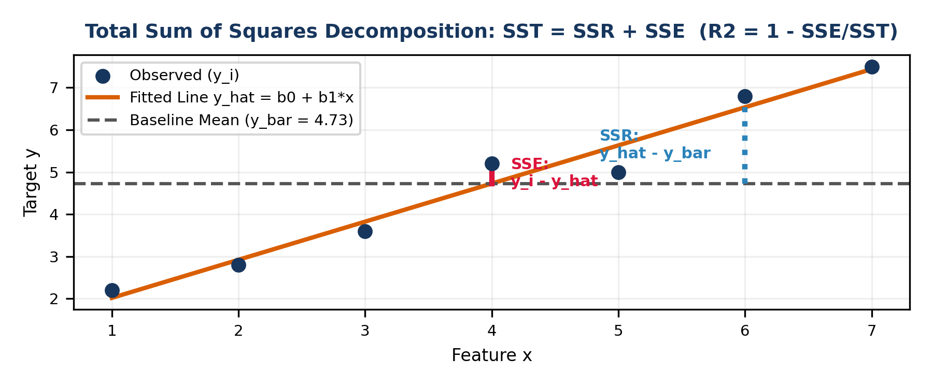
Figure 3. Sum of Squares Decomposition: Total Sum of Squares (SST) = Sum of Squares Regression (SSR) + Sum of Squared Errors (SSE).
Sum of Squares Decomposition:
SST = SSR + SSE

- SST (Total Sum of Squares): Σ (y_i − ȳ)² [Total baseline variance around mean ȳ]
- SSR (Regression Sum of Squares): Σ (ŷ_i − ȳ)² [Variance successfully explained by model]
- SSE (Error Sum of Squares): Σ (y_i − ŷ_i)² [Residual unexplained noise]

Coefficient of Determination:
R² = SSR / SST = 1 − (SSE / SST)

Interpretation of R² Values:
- R² = 1.0: Perfect predictions; SSE = 0 (model explains 100% of variance).
- R² = 0.0: Model performs identically to predicting baseline mean ȳ for all instances.
- R² < 0.0: Model performs WORSE than the baseline mean (severe overfitting or improper test fit).

7. Regularized Regression: Ridge, Lasso, and ElasticNet
When feature count d grows large or predictors are highly correlated, unconstrained OLS estimates suffer from massive variance. Regularization adds a penalty term to the OLS loss function, trading a small amount of bias for a dramatic reduction in variance.
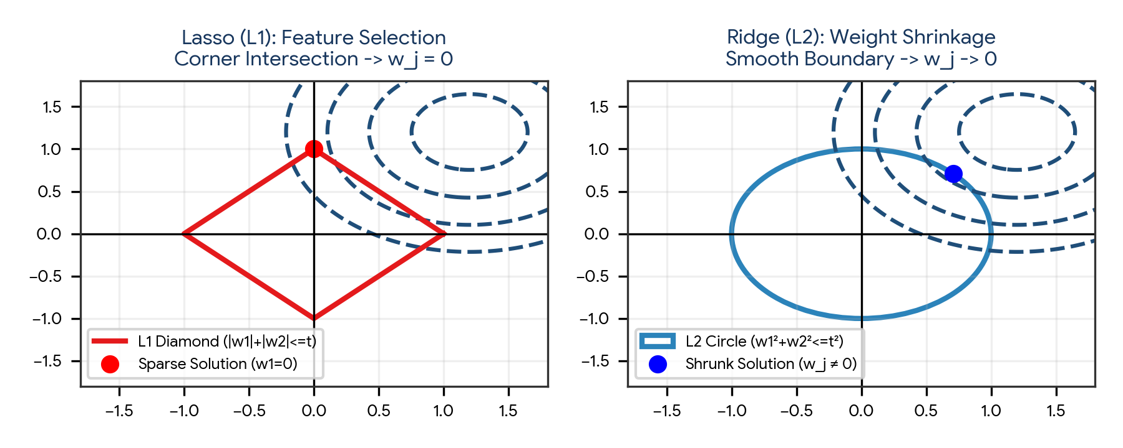
Figure 5. Geometric constraint regions: Lasso L1 diamond forces coefficients to zero; Ridge L2 circle smoothly shrinks weights.
Regularizer | Penalty Formulation | Geometric Boundary | Feature Selection? | Analytical Solution?
Ridge Regression (L2) | Loss = OLS + λ Σ [j=1 to d] β_j² | Smooth spherical L2 ball | No (shrinks β_j toward zero, never exactly zero) | Yes: β = (X^T X + λI)^(−1) X^T y
Lasso Regression (L1) | Loss = OLS + λ Σ [j=1 to d] |β_j| | Sharp diamond / polyhedron with corners on axes | Yes (drives uninformative coefficients strictly to 0) | No (requires Coordinate Descent or Subgradient)
ElasticNet Regression | Loss = OLS + λ₁ Σ |β_j| + λ₂ Σ β_j² | Rounded diamond combining L1 corners and L2 curvature | Yes (retains grouped correlated features together) | No (requires Coordinate Descent)

Critical Preprocessing Requirement: Feature Scaling
Regularization penalties (λ Σ β_j² or λ Σ |β_j|) penalize coefficient magnitudes uniformly. If features have different scales (e.g., Age in [20, 60] vs Salary in [30000, 150000]), the regularizer unfairly penalizes unscaled features with small coefficients. Therefore, StandardScaler must ALWAYS be applied before fitting regularized models.

8. End-to-End Regression Prediction Workflow
A production-ready regression workflow follows a structured sequence: Problem Definition → Exploratory Data Analysis → Leakage-Free Train/Test Partitioning → Preprocessing Pipeline → Model Fitting → Residual Diagnostics → Evaluation Benchmark.
Production Regression Workflow Architecture:

Raw Tabular Data
|
v
1. Train / Test Split (e.g., 80% Train, 20% Holdout Test)
|
v
2. Preprocessing Pipeline (Fit on Train ONLY):
- Median Imputation for missing continuous features
- One-Hot Encoding for categorical features (drop_first=True)
- StandardScaler for all features (MANDATORY for Ridge/Lasso)
|
v
3. Model Training & Cross-Validation:
- Fit OLS, Polynomial, Ridge, Lasso, ElasticNet on X_train
- 5-Fold Cross-Validation tuning regularization parameter λ (alpha)
|
v
4. Residual Diagnostics:
- Check Residuals vs Fitted (Linearity & Homoscedasticity)
- Q-Q Plot (Residual Normality)
- VIF check (Multicollinearity)
|
v
5. Final Holdout Evaluation:
- Transform X_test using fitted pipeline
- Compute MAE, MSE, RMSE, R², Adjusted R² on unseen test set

9. Practical Project — Enterprise Real Estate Valuation Pipeline
Objective: design, implement, and benchmark a complete object-oriented Python pipeline that ingests continuous real estate records, applies polynomial and interaction features, scales predictors, fits Ordinary Least Squares, Ridge, and Lasso regressors, evaluates residual diagnostics, and benchmarks generalization metrics on unseen holdout test data.

Project structure
regression_valuation_project/
|
|-- data/
| |-- property_sales.csv
|
|-- reports/
| |-- model_benchmark.csv
| |-- residual_analysis.png
|
|-- main.py
|-- requirements.txt

requirements.txt
numpy
pandas
scipy
scikit-learn
matplotlib
seaborn

Complete main.py
import os
import numpy as np
import pandas as pd
from sklearn.model_selection import train_test_split
from sklearn.preprocessing import StandardScaler, PolynomialFeatures
from sklearn.linear_model import LinearRegression, RidgeCV, LassoCV
from sklearn.metrics import mean_squared_error, mean_absolute_error, r2_score
import matplotlib.pyplot as plt
import seaborn as sns

class RealEstateRegressionEngine:
def __init__(self, n_samples=1000, random_state=42):
self.n_samples = n_samples
self.random_state = random_state
self.output_dir = "reports"
os.makedirs(self.output_dir, exist_ok=True)
self.data = None
self.scaler = None
self.models = {}
self.results = []

def generate_synthetic_real_estate_data(self):
print("=== STEP 1: DATA INGESTION & FEATURE SIMULATION ===")
np.random.seed(self.random_state)

sqft = np.random.normal(2000, 500, self.n_samples).clip(800, 4500)
bedrooms = np.random.choice([2, 3, 4, 5], size=self.n_samples, p=[0.2, 0.45, 0.25, 0.1])
age = np.random.uniform(1, 40, self.n_samples)
distance_to_center = np.random.exponential(8, self.n_samples).clip(1, 30)

# Non-linear valuation formula with interaction and Gaussian noise
price = (
150000
+ 140 * sqft
+ 18000 * bedrooms
- 1500 * age
- 4200 * distance_to_center
+ 0.015 * (sqft ** 2) # Non-linear quadratic term
- 8.0 * (sqft * distance_to_center) # Interaction term
+ np.random.normal(0, 25000, self.n_samples) # Error term ε
)

self.data = pd.DataFrame({
"Sqft": sqft.round(0),
"Bedrooms": bedrooms,
"Age": age.round(1),
"Dist_Center": distance_to_center.round(2),
"Sale_Price": price.round(2)
})
print(f"Dataset generated: {self.data.shape[0]} properties across {self.data.shape[1]} columns.")
print(self.data.describe().round(1))

def partition_data(self):
print("\n=== STEP 2: LEAKAGE-FREE TRAIN-TEST PARTITIONING ===")
X = self.data.drop(columns=["Sale_Price"])
y = self.data["Sale_Price"]

# 80% Train, 20% Holdout Test
self.X_train, self.X_test, self.y_train, self.y_test = train_test_split(
X, y, test_size=0.20, random_state=self.random_state
)
print(f"Training Instances: {self.X_train.shape[0]}, Test Instances: {self.X_test.shape[0]}")

def build_and_scale_features(self):
print("\n=== STEP 3: FEATURE EXPANSION & STANDARDIZATION ===")
# Polynomial degree 2 expansion
poly = PolynomialFeatures(degree=2, include_bias=False)
X_train_poly = poly.fit_transform(self.X_train)
X_test_poly = poly.transform(self.X_test)

self.scaler = StandardScaler()
# Fit scaler STRICTLY on training split
self.X_train_scaled = self.scaler.fit_transform(X_train_poly)
self.X_test_scaled = self.scaler.transform(X_test_poly)

self.poly_feature_names = poly.get_feature_names_out(self.X_train.columns)
print(f"Expanded feature space from {self.X_train.shape[1]} to {self.X_train_scaled.shape[1]} predictors.")

def train_and_benchmark_models(self):
print("\n=== STEP 4: MODEL TRAINING & BENCHMARKING ===")
self.models = {
"Ordinary Least Squares": LinearRegression(),
"Ridge Regression (L2)": RidgeCV(alphas=np.logspace(-2, 3, 50), cv=5),
"Lasso Regression (L1)": LassoCV(alphas=np.logspace(-1, 3, 50), cv=5, max_iter=5000, random_state=self.random_state)
}

n_test = len(self.y_test)
d_features = self.X_test_scaled.shape[1]

for name, model in self.models.items():
model.fit(self.X_train_scaled, self.y_train)
y_pred = model.predict(self.X_test_scaled)

mae = mean_absolute_error(self.y_test, y_pred)
mse = mean_squared_error(self.y_test, y_pred)
rmse = np.sqrt(mse)
r2 = r2_score(self.y_test, y_pred)
adj_r2 = 1.0 - ((1.0 - r2) * (n_test - 1) / (n_test - d_features - 1))

self.results.append({
"Model": name,
"MAE ($)": round(mae, 2),
"RMSE ($)": round(rmse, 2),
"R2_Score": round(r2, 4),
"Adjusted_R2": round(adj_r2, 4)
})

results_df = pd.DataFrame(self.results)
print(results_df.to_string(index=False))
results_df.to_csv(os.path.join(self.output_dir, "model_benchmark.csv"), index=False)
print(f"Benchmark saved to {self.output_dir}/model_benchmark.csv")

def analyze_residuals(self):
print("\n=== STEP 5: RESIDUAL DIAGNOSTICS (BEST MODEL: RIDGE) ===")
best_model = self.models["Ridge Regression (L2)"]
y_pred = best_model.predict(self.X_test_scaled)
residuals = self.y_test - y_pred

fig, axes = plt.subplots(1, 2, figsize=(10, 4))
# Residuals vs Fitted
axes[0].scatter(y_pred, residuals, alpha=0.6, color="#1F4E79")
axes[0].axhline(0, color="crimson", linestyle="--", lw=1.5)
axes[0].set_title("Residuals vs. Fitted Values (Homoscedasticity)")
axes[0].set_xlabel("Fitted Values ŷ ($)")
axes[0].set_ylabel("Residuals e ($)")

# Residuals Distribution
sns.histplot(residuals, kde=True, ax=axes[1], color="#2B83BA")
axes[1].set_title("Residual Distribution (Normality)")
axes[1].set_xlabel("Residual e ($)")

plt.tight_layout()
plt.savefig(os.path.join(self.output_dir, "residual_analysis.png"), dpi=300)
plt.close()
print(f"Residual plots saved to {self.output_dir}/residual_analysis.png")

def run(self):
self.generate_synthetic_real_estate_data()
self.partition_data()
self.build_and_scale_features()
self.train_and_benchmark_models()
self.analyze_residuals()
print("\nComplete regression valuation pipeline executed successfully.")

if __name__ == "__main__":
engine = RealEstateRegressionEngine()
engine.run()

Run the project
pip install -r requirements.txt
python main.py

Expected generated outputs
reports/
|-- model_benchmark.csv
|-- residual_analysis.png

Project notes: expanding features to polynomial degree 2 introduces interaction terms that capture physical non-linear housing dynamics. Ridge and Lasso prevent coefficient explosion and overfitting, yielding superior Adjusted R² over unregularized OLS.

10. Common Mistakes & Anti-Patterns to Avoid in Regression
- Evaluating models on training data: Reporting training R² of 0.98 while test R² is 0.42 due to severe polynomial overfitting.
- Failing to standardize features before Ridge/Lasso: Regularizing unscaled predictors unfairly penalizes features with large numeric scales.
- Confusing correlation with causation: Concluding that increasing bedrooms directly increases valuation without controlling for square footage.
- Relying exclusively on raw R² when adding features: Adding irrelevant predictors always increases raw R²; use Adjusted R² or cross-validation.
- Ignoring extreme outliers in OLS: A single severe leverage point can pivot the OLS regression slope dramatically due to quadratic error squaring.
- Interpreting coefficients under severe multicollinearity: Large VIF (> 10) inflates coefficient standard errors, causing unstable, counter-intuitive signs.
- Extrapolating predictions beyond the observed domain: Predicting real estate prices for 10,000 sqft homes when training data only spanned 1,000–3,000 sqft.

11. Quick Revision — Key Differences
Comparison | First Concept | Second Concept
MAE vs RMSE | Linear penalty |e|; robust to outliers; original units | Quadratic penalty e²; severely penalizes large errors; original units
R² vs Adjusted R² | Proportion of variance explained; monotonically rises with features | Penalizes model complexity (degrees of freedom); decreases if new feature is noise
Ridge (L2) vs Lasso (L1) | Shrinks coefficients toward zero; retains all features | Drives uninformative coefficients strictly to zero (sparse feature selection)
Simple vs Multiple Regression | Models relationship with 1 predictor: y = β₀ + β₁x + ε | Models relationship with d predictors: y = Xβ + ε
Normal Equation vs Gradient Descent | Exact analytical solution O(d³); no learning rate; slow for d > 10,000 | Iterative optimization O(knd); scales efficiently to millions of features
Homoscedasticity vs Heteroscedasticity | Constant residual variance across all predictions (valid standard errors) | Non-constant error variance (funnel shape); invalidates p-values and confidence intervals

12. Important Formulas Cheat Sheet
Concept | Mathematical Formula / Notation
Simple OLS Slope (β₁) | β₁ = Cov(x, y) / Var(x) = [ Σ (x_i − x̄)(y_i − ȳ) ] / [ Σ (x_i − x̄)² ]
Simple OLS Intercept (β₀) | β₀ = ȳ − β₁ x̄
Normal Equation Solution | β = (X^T X)^(−1) X^T y
Mean Squared Error (MSE) | MSE = (1 / n) Σ [i=1 to n] (y_i − ŷ_i)²
Root Mean Squared Error (RMSE) | RMSE = sqrt( (1 / n) Σ [i=1 to n] (y_i − ŷ_i)² )
Mean Absolute Error (MAE) | MAE = (1 / n) Σ [i=1 to n] |y_i − ŷ_i|
Coefficient of Determination (R²) | R² = 1 − (SSE / SST) = 1 − [ Σ (y_i − ŷ_i)² / Σ (y_i − ȳ)² ]
Adjusted R² | R²_adj = 1 − [ (1 − R²)(n − 1) / (n − d − 1) ]
Ridge Loss Function (L2) | Loss_Ridge = (1 / 2n) ||y − Xβ||² + λ ||β||₂²
Lasso Loss Function (L1) | Loss_Lasso = (1 / 2n) ||y − Xβ||² + λ ||β||₁
Variance Inflation Factor (VIF) | VIF_j = 1 / (1 − R_j²), where R_j² is from regressing x_j on remaining predictors

13. Interview / Viva Questions
What is the fundamental difference between linear and logistic regression?
Linear regression predicts a continuous quantitative numerical target using the identity function; logistic regression predicts a categorical probability bounded between 0 and 1 using the sigmoid function.
What does Ordinary Least Squares (OLS) minimize?
OLS minimizes the Residual Sum of Squares (RSS), which is the sum of squared vertical differences between observed target values y_i and fitted values ŷ_i.
Why is Polynomial Regression considered a linear model?
Because it is linear in the unknown parameters (coefficients β), even though the relationship between target y and feature x is non-linear.
State the five Gauss-Markov assumptions.
1. Linearity in parameters; 2. Strict exogeneity (E[ε|X] = 0); 3. Homoscedasticity (constant error variance); 4. No autocorrelation in errors; 5. No perfect multicollinearity.
What does BLUE mean in the context of the Gauss-Markov theorem?
Best Linear Unbiased Estimator: among all linear unbiased estimators, the OLS estimator achieves the lowest sampling variance.
What is heteroscedasticity and how does it impact regression models?
Heteroscedasticity occurs when error variance changes across levels of predictors (funnel shape). It does not bias coefficients, but biases standard errors, rendering p-values and confidence intervals invalid.
Why can R² be negative?
R² compares model performance to predicting the simple baseline mean ȳ. If a model fits the data worse than the horizontal mean line (common when testing an overfitted model on unseen holdout data), R² becomes negative.
Why is Adjusted R² preferred over raw R² in multiple regression?
Because raw R² never decreases when new features are added, even if they are pure noise. Adjusted R² penalizes adding uninformative features by accounting for degrees of freedom.
What is the difference between MAE and RMSE?
MAE treats all errors linearly and is robust to outliers; RMSE squares errors before averaging, heavily penalizing large individual prediction errors.
When should you choose MAE over RMSE?
Choose MAE when outliers are present in target data or when the business cost of an error scales strictly linearly with error magnitude.
What is multicollinearity and how is it detected?
Multicollinearity occurs when two or more predictor features are highly linearly correlated. It is detected using correlation heatmaps (|r| > 0.85) or Variance Inflation Factor (VIF > 5.0).
How does Ridge regression differ from Lasso regression?
Ridge (L2) adds a squared penalty shrinking coefficients toward zero without eliminating them; Lasso (L1) adds an absolute penalty that drives uninformative coefficients strictly to zero, performing automated feature selection.
Why does Lasso produce sparse coefficients while Ridge does not?
Geometrically, the L1 constraint region is a diamond with sharp corners situated on the parameter axes. The elliptical OLS loss contours frequently intersect these corners, setting parameters exactly to zero.
Why is feature scaling mandatory before fitting Ridge or Lasso?
Because the penalty terms (λ Σ β_j² or λ Σ |β_j|) penalize coefficients equally. Unscaled features with large ranges naturally have tiny coefficients and escape regularization penalties unfairly.
What is ElasticNet regression and when should you use it?
ElasticNet linearly blends L1 and L2 penalties. Use it when there are multiple correlated features and you want sparse selection while retaining groups of correlated predictors.
What happens to OLS when features are perfectly collinear?
The matrix (X^T X) becomes singular (non-invertible) with determinant 0, making the Normal Equation β = (X^T X)^(−1) X^T y impossible to solve.
What is the Hat Matrix in linear regression?
The Hat matrix H = X(X^T X)^(−1) X^T projects observed values y onto fitted values ŷ (ŷ = Hy). Its diagonal elements represent data leverage points.
What is the difference between an outlier and a high leverage point?
An outlier has a large residual (far from the regression line in the y-dimension); a high leverage point has extreme predictor values (far from the feature mean in the x-dimension).
Why does the Normal Equation scale poorly to massive datasets?
Because computing (X^T X)^(−1) has cubic computational complexity O(d³). When d > 10,000 features, matrix inversion becomes computationally prohibitive; Gradient Descent is preferred.
How do you detect residual normality in regression?
By plotting a Q-Q (Quantile-Quantile) plot or running statistical normality tests like the Shapiro-Wilk or Jarque-Bera tests on residuals.

14. Coding Practice
- Derive and implement Simple Linear Regression from scratch in pure Python using NumPy without scikit-learn.
- Implement the closed-form Normal Equation β = (X^T X)^(−1) X^T y and verify coefficients match scikit-learn LinearRegression.
- Fit polynomial regression models of degrees 1, 2, 5, and 15 on noisy non-linear data and plot their regression curves.
- Write a diagnostic script that generates Residuals vs. Fitted and Q-Q plots for an OLS model and checks for heteroscedasticity.
- Calculate the Variance Inflation Factor (VIF) for all features in a DataFrame and drop features with VIF > 5.0.
- Implement a custom evaluation function that returns MAE, MSE, RMSE, MAPE, R², and Adjusted R² given true and predicted arrays.
- Simulate an outlier-contaminated dataset and compare how MAE and RMSE change as outlier magnitude increases.
- Implement a leak-free scikit-learn Pipeline combining PolynomialFeatures(degree=2), StandardScaler(), and RidgeCV().
- Fit a LassoCV model on a dataset with 50 features where only 5 are truly informative, and print the non-zero selected coefficients.
- Perform 5-fold cross-validation comparing Linear Regression, Ridge, Lasso, and ElasticNet on a real estate pricing dataset.
- Demonstrate data leakage by standardizing a dataset before train-test split vs inside a pipeline, and observe the test metric shift.
- Extend the real estate valuation project to export a CSV of predicted vs actual sales prices along with 95% prediction intervals.

15. Day 391 Completion Checklist
- ☐ Understand the mathematical foundations of Simple and Multiple Linear Regression.
- ☐ Derive OLS slope and intercept formulas and understand the Normal Equation.
- ☐ Model non-linear relationships using Polynomial Regression and manage degree overfitting.
- ☐ State and test the five Gauss-Markov assumptions (Linearity, Exogeneity, Homoscedasticity, Independence, Multicollinearity).
- ☐ Calculate and interpret MAE, MSE, RMSE, MAPE, R², and Adjusted R².
- ☐ Decompose Total Sum of Squares into Regression Sum of Squares and Residual Sum of Squares (SST = SSR + SSE).
- ☐ Differentiate Ridge (L2 shrinkage) and Lasso (L1 feature selection) regularization.
- ☐ Explain why feature scaling is mandatory prior to regularized regression.
- ☐ Execute the complete 5-stage regression prediction workflow.
- ☐ Build and run the practical Real Estate Valuation Pipeline project.
- ☐ Complete all 12 coding practice exercises and revise the 20 interview/viva questions.

16. Learning Outcomes
After completing this revision, you should be able to:
- Formulate, fit, and interpret Simple, Multiple, and Polynomial regression models.
- Diagnose violations of Gauss-Markov assumptions using residual plots, Q-Q plots, and VIF metrics.
- Select appropriate evaluation metrics (MAE vs RMSE vs R²) based on outlier sensitivity and business goals.
- Apply Ridge and Lasso regularization to mitigate multicollinearity and prevent overfitting.
- Construct modular, leak-free regression pipelines combining feature transformers, scalers, and cross-validated estimators.
Next recommended topic: Day 392 — Classification Algorithms Revision: Logistic Regression, Decision Trees, Random Forests, Support Vector Machines (SVM), and Classification Metrics (Precision, Recall, F1, ROC-AUC).

